

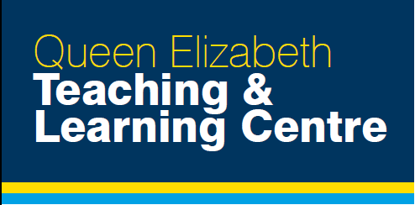

**Agenda/Timings**

* The course registration opens at 8am on the Thursday with the course starting at 8.10am prompt.
* On Friday the course starts at 8.10am.
* The course will close at 5pm each day.
* You will complete two full exams each day.
  + Time in between your exams will be spent doing informal exam practice with each other using premade booklets with exam questions.

**New course format**

* As you will be aware the exam format is changing from Dec 2018.
* The consultant lead exam practice will follow the new exam format.
* For the self directed informal candidate practice will have access to booklets with premade exam questions with answers.

**Location**

* The course is held in the Teaching and Learning Centre within the Queen Elizabeth University Hospital Glasgow.
* This is located in the southside of Glasgow.
* Driving directions and public transport options are included below.
* We have also attached a map of the hospital with the location of the Teaching and Learning Centre and parking options.

**Parking**

* We advise parking in the multistory carpark P2.
* This is located directly adjacent to the Teaching and Learning Centre
* When entering the car park if the attendant askes state you are attending a course at the Teaching and Learning Centre

**Travel Information**

**By Car**:

Use postcode G51 4TF to get to the campus,

* **From the East or West of the City**
  + M8 motorway to Junction 25.
  + Follow signs for Clyde Tunnel (A739) for ¾ mile.
  + Then follow signs for South Glasgow University Hospital. Turn left into Govan Road. The hospital is on the left.
* **From north of the River Clyde**
  + Go through the Clyde Tunnel (A739) and follow the signs for the hospital

**By Train/underground:**

 To Govan Road Entrance

* Govan Subway Station:
* A 25 minute walk to Govan Road entrance (just over 1 mile). Buses for hospital grounds are at street level bus stop, not the terminus. The X19 and 23/23A connect Govan Subway to Arrivals Square and the 90 to the Hospital grounds on Langlands Drive.
* Central Station (Union Street) (nearest buses):  
  McGill's 23, 23A or Stagecoach X19. Alternatively take the St Enoch Subway to Govan and follow the above directions.
* Queen Street Station:  
  Stagecoach X19 or First 77 from Cathedral Street. Alternatively, take the Buchanan Street Subway to Govan and follow the above directions.
* Cardonald Station:   
  A 25 minute walk to Langlands Road entrance (just over 1 mile) or McGill's bus 17, First 34a, Colchri 25.
* Paisley Gilmour Street Station:  
  McGill's 17.

.